[1]

Preparation of Final Report for Advanced Mechatronics Course at Ontario Tech

Name (Student No.)

*Abstract*—These instructions give you guidelines for preparing final report for Advanced Mechatronics Course*.* Use this document as a template Define all symbols used in the abstract.

*Index Terms*—About four key words or phrases in alphabetical order, separated by commas.

# INTRODUCTION

T

HIS document is a template for Microsoft *Word* versions 6.0 or later. And It is prepared as the template for the final reports of ENGR 5263G Advanced Control Course at OntarioTech.

Peer evaluations will be handed out at the end of the semester. Cheating, plagiarism, or any other form of Academic Misconduct as outlined in Section 5.15 of the OntarioTech Calendar will be PUNISHED to the fullest extent.

# Procedure for Report Submission

## Proposal (1-2 page)

The project proposal should provide a basic description of your project, including 1) Title of project, 2) Project abstract; 3) Project scenario and goals, 4) Possible challenges, 5) Reference and background information.

## Final Report (6-8 pages)

Final report should be a complete technical document including introduction, literature review, methodology, simulation and experimentation results, and conclusion. It should be considered as an engineering paper which is planning to be published in engineering conferences or journals.

# Helpful Hints

## Figures and Tables

If your figure has two parts, include the labels “(a)” and “(b)” as part of the artwork. Please verify that the figures and tables you mention in the text actually exist. **Please do not include captions as part of the figures. Do not put captions in “text boxes” linked to the figures. Do not put borders around the outside of your figures.** Use the abbreviation “Fig.” even at the beginning of a sentence. Do not abbreviate “Table.” Tables are numbered with Roman numerals.

Figure axis labels are often a source of confusion. Use words rather than symbols. As an example, write the quantity “Magnetization,” or “Magnetization *M*,” not just “*M*.” Put units in parentheses. Do not label axes only with units. As in Fig. 1, for example, write “Magnetization (A/m)” or “Magnetization (Am−1),” not just “A/m.” Do not label axes with a ratio of quantities and units. For example, write “Temperature (K),” not “Temperature/K.”

Please check the figure and table below for reference.

Units for Magnetic Properties

|  |  |  |
| --- | --- | --- |
| Symbol | Quantity | Conversion from Gaussian and  CGS EMU to SI a |
| Φ | magnetic flux | 1 Mx → 10−8 Wb = 10−8 V·s |
| *B* | magnetic flux density,  magnetic induction | 1 G → 10−4 T = 10−4 Wb/m2 |
| *H* | magnetic field strength | 1 Oe → 103/(4π) A/m |
| *m* | magnetic moment | 1 erg/G = 1 emu  → 10−3 A·m2 = 10−3 J/T |
| *M* | magnetization | 1 erg/(G·cm3) = 1 emu/cm3  → 103 A/m |
| 4π*M* | magnetization | 1 G → 103/(4π) A/m |
| σ | specific magnetization | 1 erg/(G·g) = 1 emu/g → 1 A·m2/kg |
| *j* | magnetic dipole  moment | 1 erg/G = 1 emu  → 4π × 10−10 Wb·m |
| *J* | magnetic polarization | 1 erg/(G·cm3) = 1 emu/cm3  → 4π × 10−4 T |
| χ*,* κ | susceptibility | 1 → 4π |
| χρ | mass susceptibility | 1 cm3/g → 4π × 10−3 m3/kg |
| μ | permeability | 1 → 4π × 10−7 H/m  = 4π × 10−7 Wb/(A·m) |
| μr | relative permeability | μ → μr |
| *w, W* | energy density | 1 erg/cm3 → 10−1 J/m3 |
| *N, D* | demagnetizing factor | 1 → 1/(4π) |

Vertical lines are optional in tables. Statements that serve as captions for the entire table do not need footnote letters.

aGaussian units are the same as cgs emu for magnetostatics; Mx = maxwell, G = gauss, Oe = oersted; Wb = weber, V = volt, s = second, T = tesla, m = meter, A = ampere, J = joule, kg = kilogram, H = henry.

## MATH

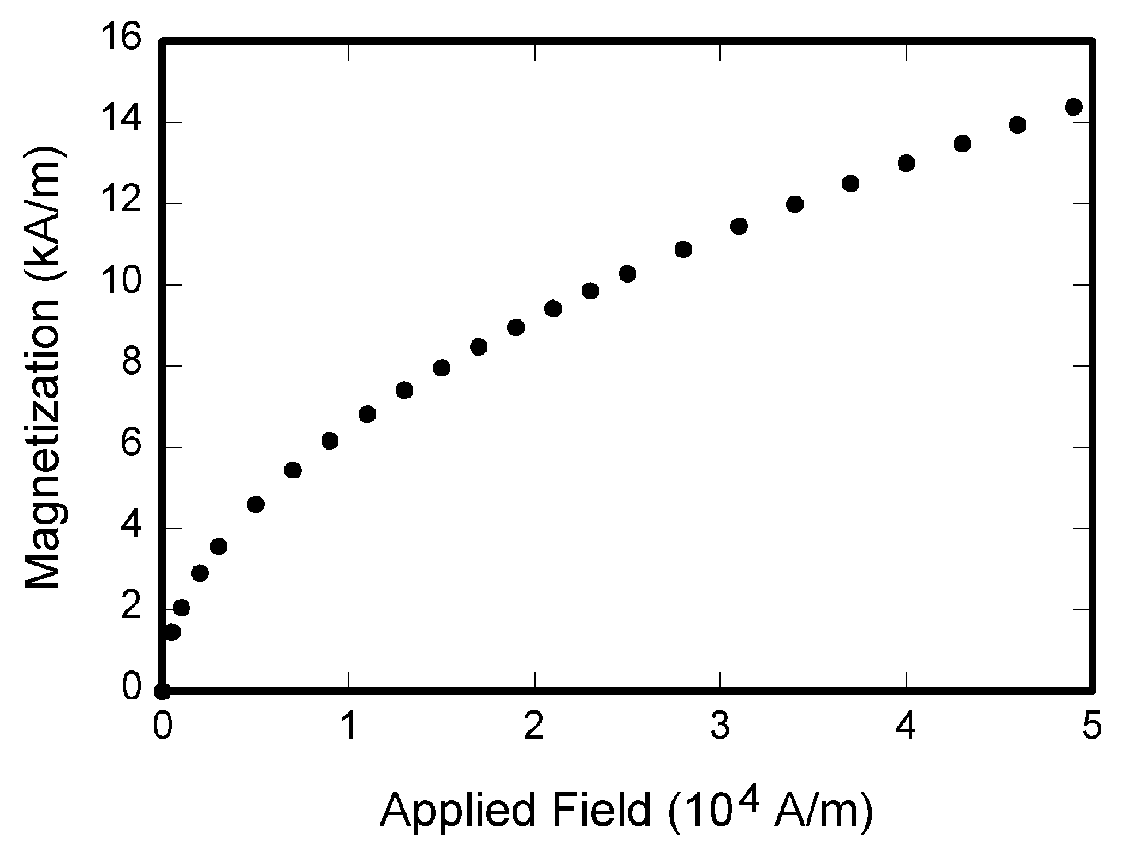

Fig. 1. Magnetization as a function of applied field. Note that “Fig.” is abbreviated. There is a period after the figure number, followed by two spaces. It is good practice to explain the significance of the figure in the caption.

If you are using *Word,* use either the Microsoft Equation Editor or the *MathType* add-on (http://www.mathtype.com) for equations in your paper (Insert | Object | Create New | Microsoft Equation *or* MathType Equation). “Float over text” should *not* be selected.

## References

Number citations consecutively in square brackets [1]. The sentence punctuation follows the brackets [2]. Multiple references [2], [3] are each numbered with separate brackets [1]–[3]. When citing a section in a book, please give the relevant page numbers [2]. In sentences, refer simply to the reference number, as in [3]. Do not use “Ref. [3]” or “reference [3]” except at the beginning of a sentence: “Reference [3] shows ... .” Please do not use automatic endnotes in *Word*, rather, type the reference list at the end of the paper using the “References” style.

# Conclusion

A conclusion may review the main points of the report, highlighting the contributions of your work in the given report and suggesting possible improvement and extension in future work.

Appendix

Attached the main/key reference paper or document as the appendix.

References

1. G. O. Young, “Synthetic structure of industrial plastics (Book style with paper title and editor),” in *Plastics*, 2nd ed. vol. 3, J. Peters, Ed. New York: McGraw-Hill, 1964, pp. 15–64.
2. W.-K. Chen, *Linear Networks and Systems* (Book style)*.* Belmont, CA: Wadsworth, 1993, pp. 123–135.
3. H. Poor, *An Introduction to Signal Detection and Estimation*. New York: Springer-Verlag, 1985, ch. 4.

1.